Programming Exercise 6:

Support Vector Machines

Machine Learning

Student Name: Ethan Hitchcock

PeopleSoft ID: 1408202

Question (1) **(25 points)**

Please compute the Gaussian Kernel between two examples:

(x1 = [1; 2; 1], x2 = [0; 4; -1], sigma = 0.5)

GK = 0.324652

Question (2) **(25 points)**

Best sigma for Gaussian kernel and plot SVM (Gaussian Kernel) decision boundary for example dataset 3:

sigma = 0.10

figure:

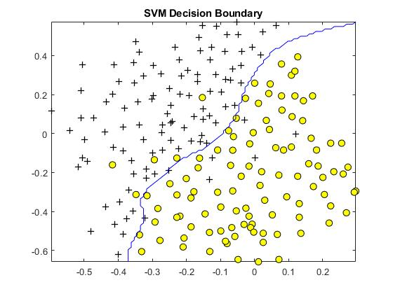

Question (3) **(25points)**

Please give the word indices vector for a given email (emailSample1.txt)

Word indices = [ 86 916 794 1077 883 370 1699 790 1822 1831 883 431 1171 794 1002 1893 1364 592 1676 238 162 89 688 945 1663 1120 1062 1699 375 1162 479 1893 1510 799 1182 1237 810 1895 1440 1547 181 1699 1758 1896 688 1676 992 961 1477 71 530 1699 531 ]

Question (4) **(25 points)**

Please compute Training accuracy and test accuracy for the given spam email dataset and test dataset:

Training accuracy = 99.825000

Test accuracy = 98.800000